**ADDING FOLDER**

1. First, right click temporary place then select Add and Folder

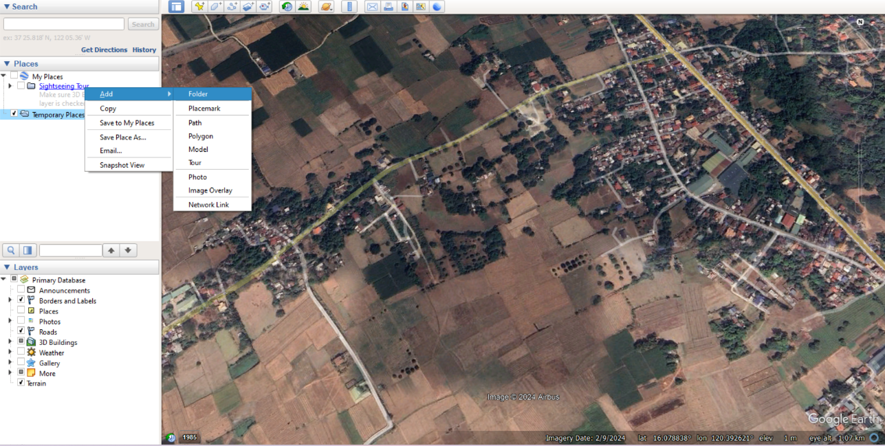

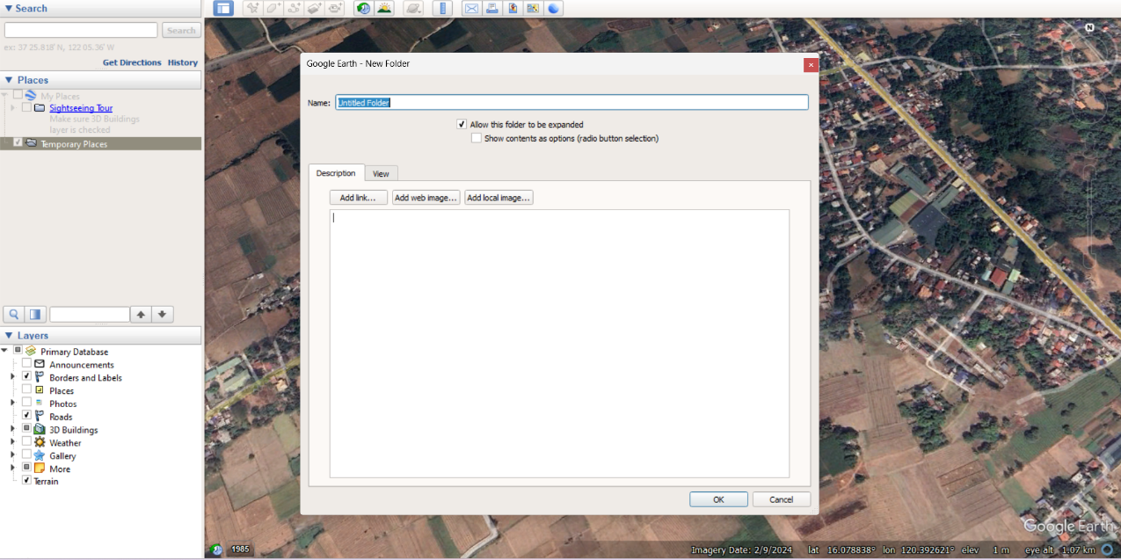

1. Next, type Folder name then click ok.

**ADDING PLACEMARK**

1. Right click the folder created then click Add and Placemark.

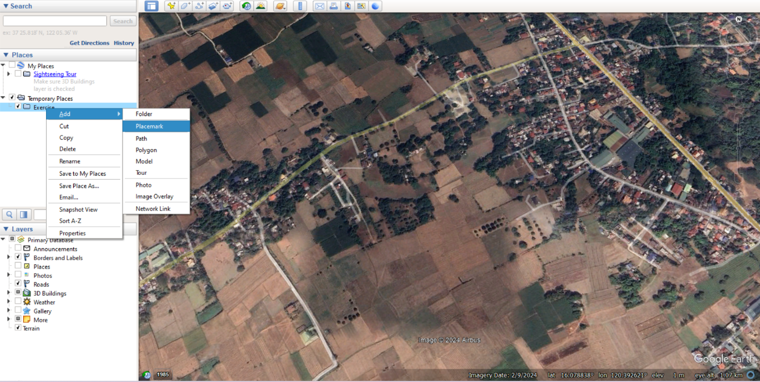

1. Move the created Placemark on your desired place then click ok. (you *can also change the name of the placemark*)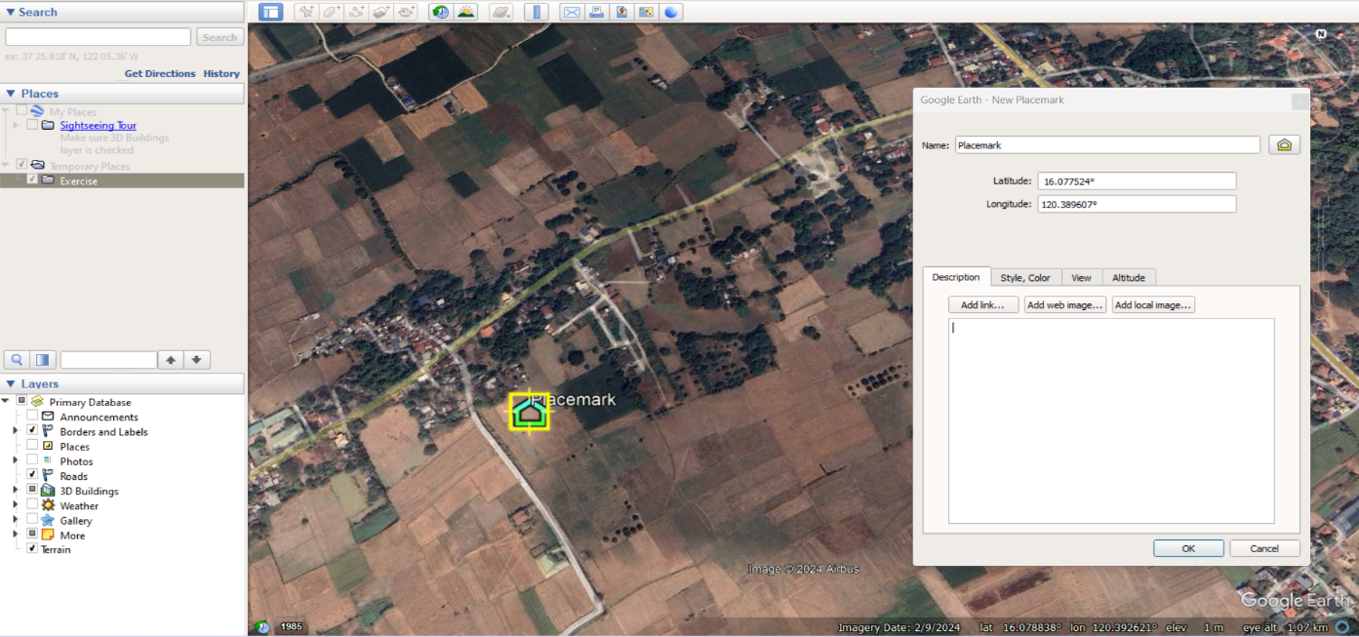

**ADDING PATH**

5. Right click the folder created then click Add and Path.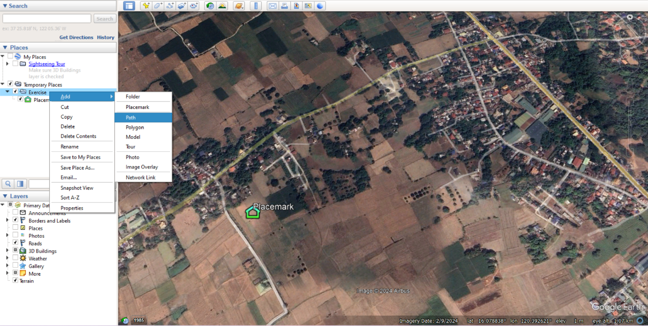

6. Click the place per point on desired location of the Path and click ok. (you *can also change the name of the Path*)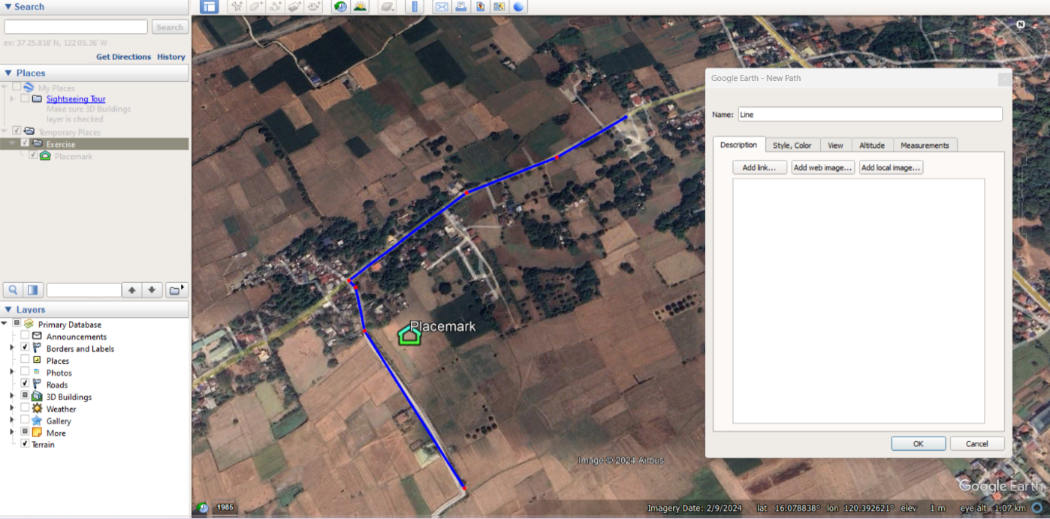

**ADDING POLYGON**

7. Right click the folder created then click Add and Polygon.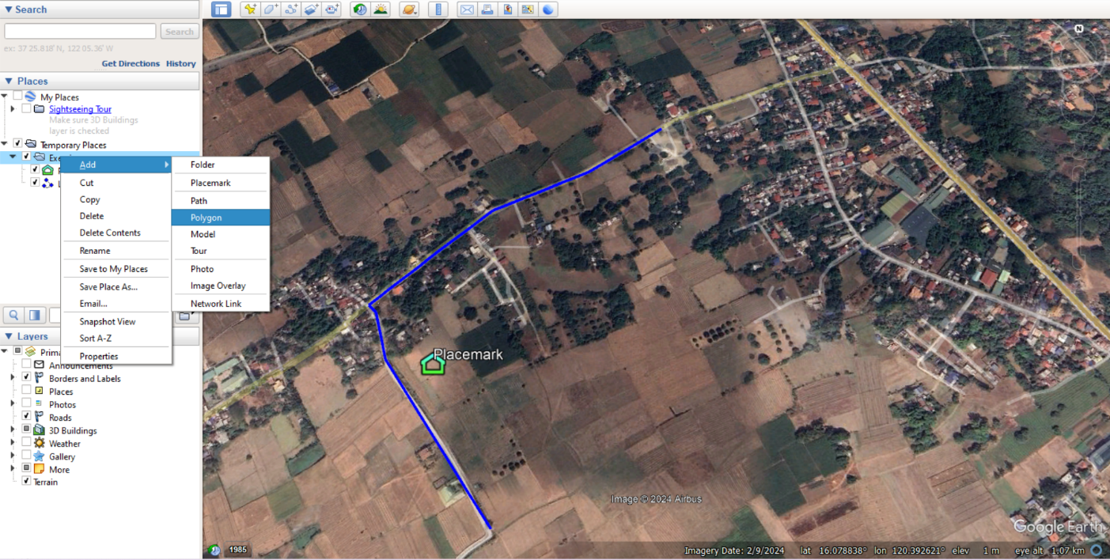

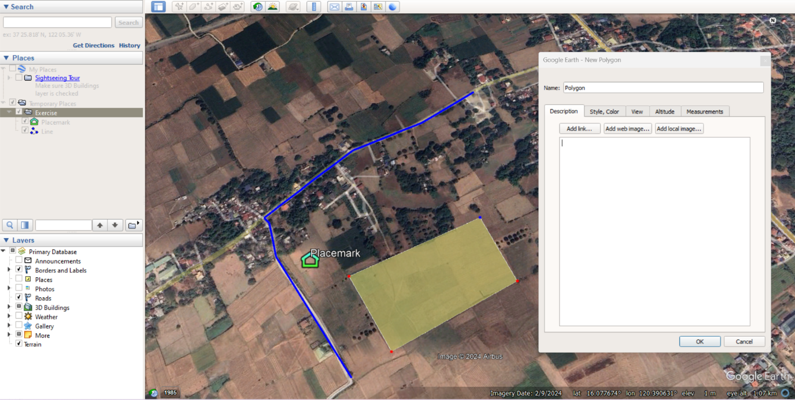

8. Click of the place you want to create a Polygon per sides then click ok. (you *can also change the name of the Polygon*)

**CHANGING COLOR/STYLE LAYOUT**

9. You can also edit color or opacity in the Style, Color tab then click ok.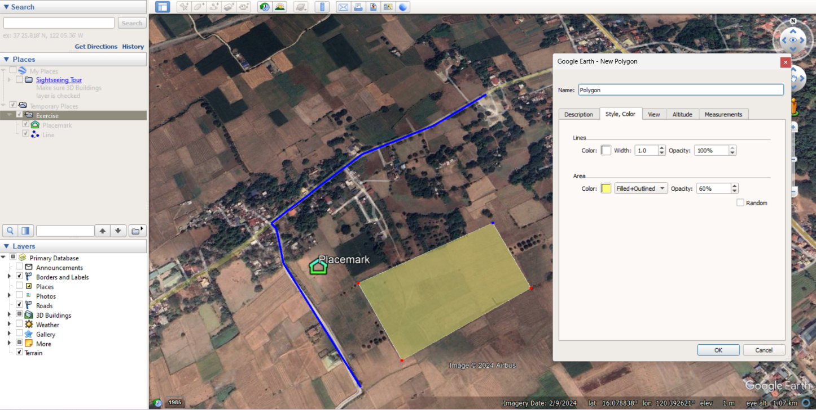

**SAVE FOLDER AS KMZ/KML FILE**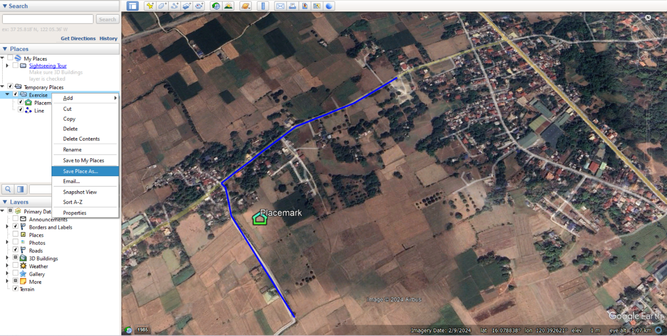

10. To Save the file created, Right click the folder Exercise then select Save place as.

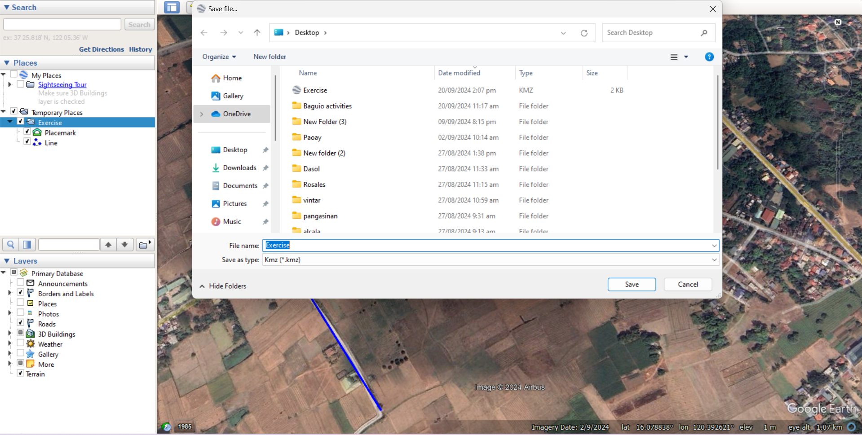

11. Put the desired file name, then save as KMZ then click Save.